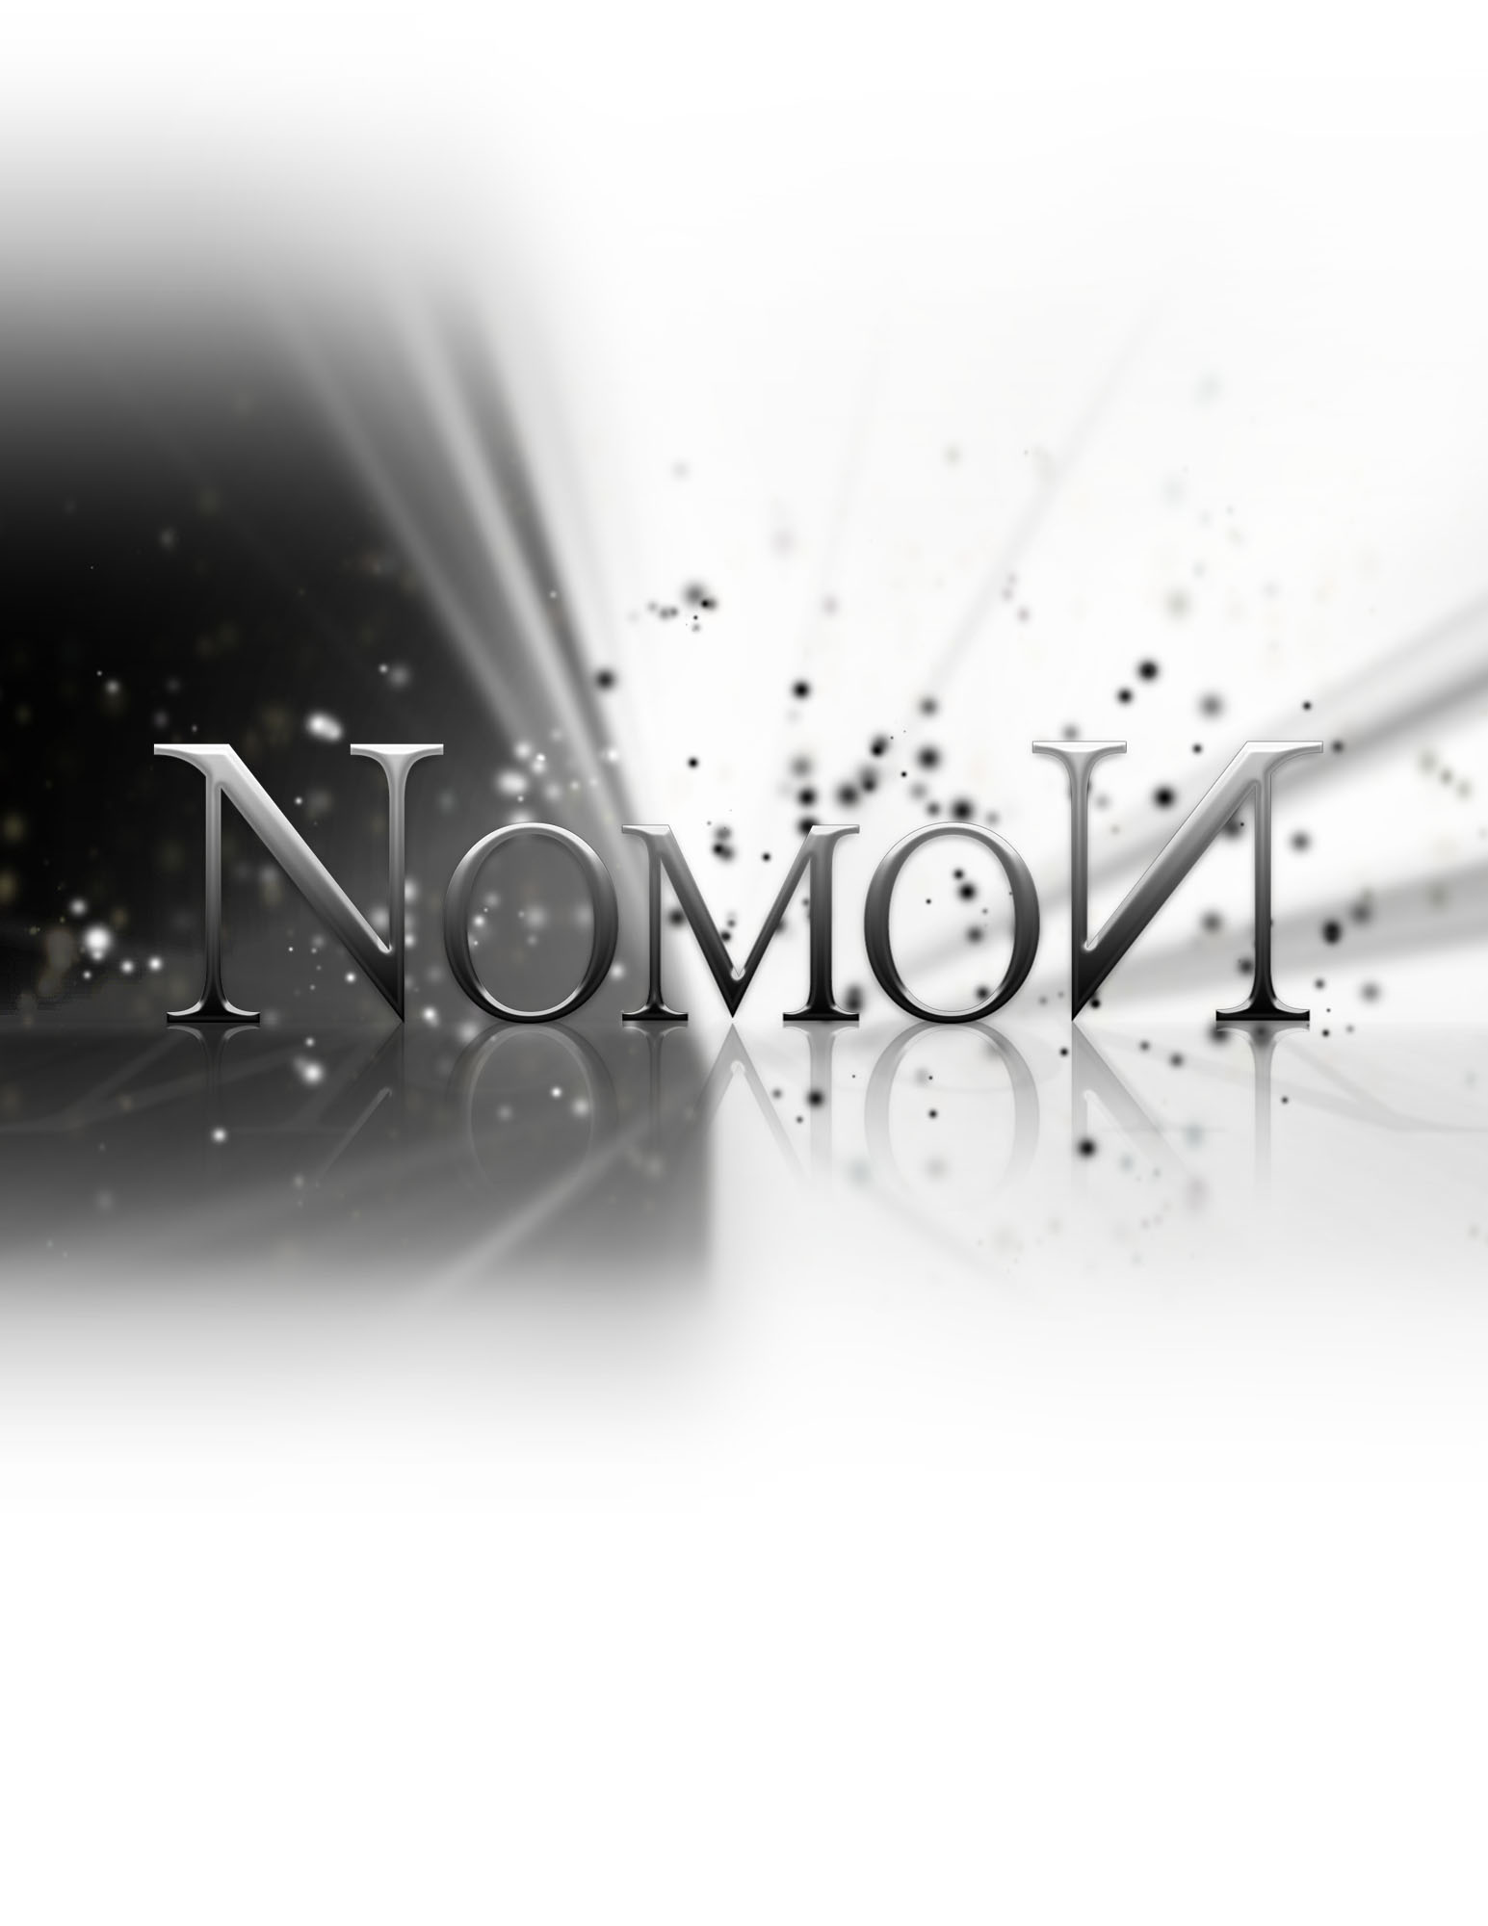
Status Report

Friday, October 14, 2011

Status Report

The List of Tasks to be done by this period:
  - Design Document and Advertisement - October 11th 2011
  - Gameplay Prototype - October 14th 2011

Tasks underway:

Concept Art - 70% Complete
Worked on by Sarah (20%), Shaughn (30%), Adam (10%), Tom (10%)

Art Research - 90% Complete
Sarah (50%), Shaughn (40%)

Research into the unreal engine - 90% Complete
Tom (50%), Nik (20%), Adam (20%)

Platformer tutorial - 70% Complete
Nik (30%), Adam (30%), Tom (10%)

Shader research - 100% Complete
Tom (100%)

Web Design - 70% Complete
Shaughn (50%), Sarah (20%)

Modelling - 5% Complete
Tom (5%)

We will need to implement the following functionality:
- Light/shadow detection: The game will need to detect if the player is in range of a light source. By casting a ray from all nearby lights towards the player, developers can test if the ray is able to strike the player without a collision with the terrain. If it collides, one can determine that the player is lit.
- Object carrying mechanic: Certain objects need to be able to be carried. Developers need to simply code in a few triggers and have a supporting character animation to enable this.
- Enemy movement: Enemies will be patrolling levels at certain points. By leveraging brushes, one can constrain their movements and have them only patrol a small area.
- Enemy as a platform: When enemies are “inactive” they can be used as platforms. This will simply have to be an internal switch of some sort.
- Light/shadow switching: Lights in the UDK can be turned on and off. This will affect gameplay, and thus will need to have special attention.

We also need to finalize art style, concept art, and continue working on the website.

List of Tasks Accomplished by their appropriate date:
- Design Document and Advertisement - October 11th 2011

The website is available at http://ds4.abielinski.com/

List of delivered results of the tasks (files, etc)

- PDF File - Design Document
- Website URL
- JPG of Advertisement - Flyer
- PSD, AI and compressed files - Concept art

Challenges and problems faced

Forgetting
The gameplay prototype was completely forgotten about during the last few weeks. This could mainly be blamed on the amount of other work that has been given to us, distracting us from our other important goals. For the past month the team’s focus has been on Senior Project, so other tasks have fallen to the wayside.

Getting started with so many other projects to do it is difficult to work on multiple ones at the same time. Other distractions such as games and social lives also get in the way.

Solution: allocate more segregated work time for each project, rather than letting imminent deadlines dictate the workflow.

Starting to Understand the Engine
Getting the motivation to start working on learning the UDK was difficult, but after we had the tutorial there was a large boost in interest into getting the project started. Since there has been a large headway made in understanding the engine.

Solution: Dedicated time to go over tutorials and general time to play around with the engine to get more familiar with it.

